

|  |
| --- |
| Funnel Analysis Report  Business Case: Swiggy |
|  |
| Skillovilla Capstone project  By: Dhivyalakshmi K B |

# Business Case: Swiggy

Swiggy is one of the largest food ecommerce platform in the country. Every day more than 1 million users are transacting on the platform.

The workbook has 6 sheets :

Session Details : sheet has date wise session count. It contains listing sessions, menu sessions, cart sessions, payment sessions and order sessions day over day

Channel wise traffic : sheet has traffic (listing sessions) breakup at date level.

Supporting Data sheet : It has other information at date level

Funnel Analysis : Order change, Traffic change, conversion change is calculated and Positive and negative peaks are identified

Average Conversion Rates : Average conversion rates for positive and negative peaks are calculated

Pivot & graph : Contains necessary pivots tables and associated graphs

Month wise Analysis :

|  |  |  |  |
| --- | --- | --- | --- |
| Row Labels | Average of Average Discount | Sum of Average Packaging charges | Sum of Average Delivery Charges |
| Jan | 17.88% | 634 | 877 |
| Feb | 17.86% | 544 | 765 |
| Mar | 18.03% | 602 | 883 |
| Apr | 17.90% | 581 | 813 |
| May | 17.87% | 606 | 844 |
| Jun | 17.77% | 592 | 836 |
| Jul | 17.94% | 616 | 854 |
| Aug | 18.19% | 622 | 869 |
| Sep | 18.17% | 588 | 834 |
| Oct | 18.13% | 616 | 856 |
| Nov | 18.40% | 598 | 814 |
| Dec | 17.97% | 600 | 842 |
| Grand Total | 18.01% | 7199 | 10087 |

From the monthly analysis, we could see November has more discounted prices of 18.40% due to festive seasons

May month has least discounts of 17.77% which can be due to summer vacations and there will be neither a decrease or Increase in order intake

February month observes less Packaging charges and Delivery charges when compared to other months

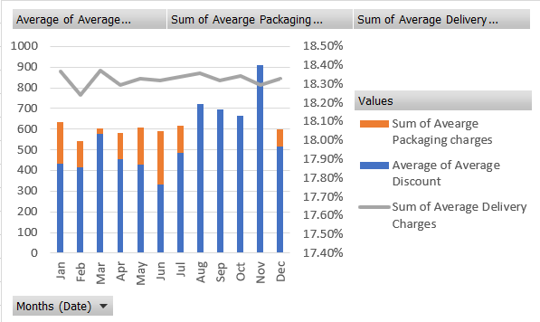

Identifying Peaks from each month

Negative Peaks

From the Order change, traffic change and conversion change when compared to same day last week, the days having negative results are grouped as Negative peak and the source of decline in traffic is identified as given in the table below

|  |  |  |  |  |
| --- | --- | --- | --- | --- |
| Negative Peak | | | | |
| Date | Order Change with respect to same day last week | Traffic Change with respect to same day last week | Conversion change with respect to same day last week | Channel wise traffic change |
| 10-01-2019 | -45.23% | -48.96% | 7.31% | Decline in traffic from Facebook |
| 29-01-2019 | -71.71% | -40.46% | -52.48% | Negligible decline in traffic |
| 19-02-2019 | -55.84% | -3.81% | -54.09% | Negligible decline in traffic |
| 02-03-2019 | -37.59% | 8.33% | -42.39% | Negligible decline in traffic |
| 19-03-2019 | -45.55% | 2.02% | -46.63% | Negligible decline in traffic |
| 04-04-2019 | -52.09% | 3.03% | -53.50% | Negligible decline in traffic |
| 12-04-2019 | -27.31% | -8.65% | -20.43% | Negligible decline in traffic |
| 25-04-2019 | -38.69% | 0.00% | -38.69% | Negligible decline in traffic |
| 20-06-2019 | -54.37% | -53.00% | -2.92% | Decline in traffic detected from all Channels |
| 16-07-2019 | -63.08% | -9.52% | -59.20% | Negligible decline in traffic |
| 11-08-2019 | -54.35% | 0.00% | -54.35% | Negligible decline in traffic |
| 14-09-2019 | -53.59% | -4.81% | -51.25% | Negligible decline in traffic |
| 17-11-2019 | -57.00% | -6.67% | -53.93% | Negligible decline in traffic |

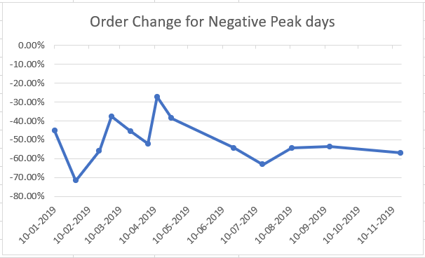

Positive Peaks

From the Order change, traffic change and conversion change when compared to same day last week, the days having high positive results are grouped as Positive peak and the source of Increase in traffic is identified as given in the table below

|  |  |  |  |  |
| --- | --- | --- | --- | --- |
| Positive Peak | | | | |
| Date | Order Change with respect to same day last week | Traffic Change with respect to same day last week | Conversion change with respect to same day last week | Channel wise traffic change |
| 17-01-2019 | 105.95% | 110.20% | -2.02% | Usual traffic |
| 21-01-2019 | 23.35% | 5.15% | 17.31% | Usual traffic |
| 22-01-2019 | 85.43% | 76.53% | 5.04% | Increase in traffic from twitter |
| 31-01-2019 | 20.06% | 1.05% | 18.81% | Usual traffic |
| 05-02-2019 | 114.77% | 0.00% | 114.77% | Usual traffic |
| 26-02-2019 | 120.04% | 1.98% | 115.77% | Usual traffic |
| 28-02-2019 | 22.32% | 8.33% | 12.92% | Usual traffic |
| 09-03-2019 | 102.02% | 0.00% | 102.02% | Increase in traffic from Facebook |
| 24-03-2019 | 22.26% | 6.32% | 15.00% | Increase in traffic from Facebook |
| 26-03-2019 | 77.96% | -4.95% | 87.23% | Usual traffic |
| 11-04-2019 | 92.39% | -6.86% | 106.57% | Usual traffic |
| 14-04-2019 | 28.38% | 8.33% | 18.50% | Increase in traffic from Facebook |
| 18-04-2019 | 73.02% | 10.53% | 56.54% | Usual traffic |
| 19-04-2019 | 24.72% | 7.37% | 16.17% | Usual traffic |
| 27-06-2019 | 114.72% | 119.15% | -2.02% | Usual traffic |
| 23-07-2019 | 135.03% | 3.16% | 127.84% | Usual traffic |
| 18-08-2019 | 106.62% | 3.06% | 100.48% | Increase in traffic from Facebook |
| 21-09-2019 | 111.53% | -1.01% | 113.69% | Increase in traffic from Facebook |
| 09-10-2019 | 21.87% | -4.04% | 27.00% | Usual traffic |
| 21-10-2019 | 32.38% | 9.38% | 21.04% | Usual traffic |
| 09-11-2019 | 26.26% | 7.37% | 17.60% | Gradual Increase in traffic from All Channels due to possible festive seasons/ Discounts |
| 24-11-2019 | 135.48% | 5.10% | 124.05% | Gradual Increase in traffic from All Channels due to possible festive seasons/ Discounts |
| 01-12-2019 | 20.75% | 0.97% | 19.59% | Gradual Increase in traffic from All Channels due to possible festive seasons/ Discounts |
| 22-12-2019 | 21.03% | 0.00% | 21.03% | Gradual Increase in traffic from All Channels due to possible festive seasons/ Discounts |

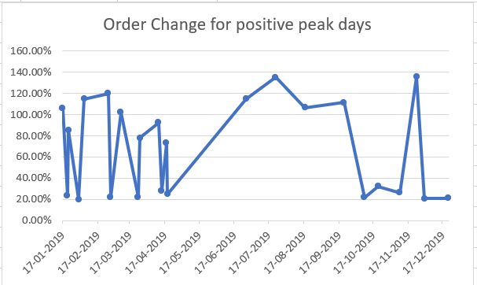

January

|  |  |  |  |  |
| --- | --- | --- | --- | --- |
| Channel traffic | | | | |
| Row Labels | Average of Facebook % | Average of Youtube% | Average of Twitter% | Average of Others% |
| 10-01-2019 | 3.64% | 27.00% | 11.00% | 58.36% |
| 17-01-2019 | 36.00% | 27.00% | 11.00% | 26.00% |
| 22-01-2019 | 36.00% | 5.40% | 52.77% | 5.83% |
| 29-01-2019 | 36.00% | 27.00% | 11.00% | 26.00% |
| Grand Total | 27.91% | 21.60% | 21.44% | 29.05% |

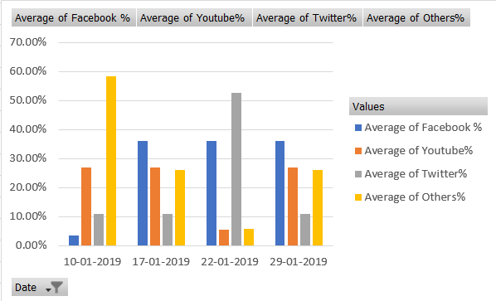

On 10th Jan there is a less traffic observed from facebook and avg. cost of two is Rs.399 which is higher than other days

Similarly on 29th Jan, there is overall decline in order intake when compared to same day last week – 22nd Jan

On 22nd Jan there is an Increase in traffic from Twitter which covers the decline in traffic from facebook and other sources

February

|  |  |  |  |  |
| --- | --- | --- | --- | --- |
| Channel traffic | | | | |
| Row Labels | Average of Facebook % | Average of Youtube% | Average of Twitter% | Average of Others% |
| 19-02-2019 | 36.00% | 27.00% | 11.00% | 26.00% |
| 26-02-2019 | 36.00% | 27.00% | 11.00% | 26.00% |
| Grand Total | 36.00% | 27.00% | 11.00% | 26.00% |

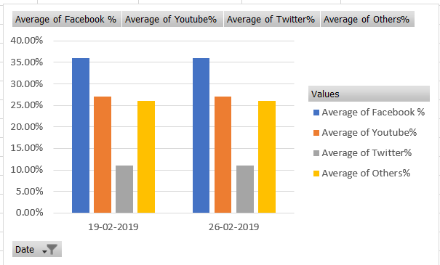

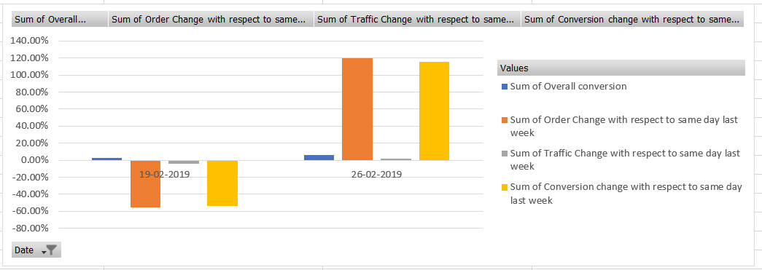

On 19th feb, the order rates and Conversion rates are in Negative thought the traffic from sources remain unchanged

On 26th feb, the overall conversion rate is 6.10% and successful payment rate is 95%

March

|  |  |  |  |  |
| --- | --- | --- | --- | --- |
| Charges during peak days | | | | |
| Row Labels | Sum of Average Discount | Sum of Avearge Packaging charges | Sum of Average Delivery Charges | Sum of Success Rate of payments |
| 02-03-2019 | 18% | 18 | 56 | 95% |
| 09-03-2019 | 17% | 21 | 28 | 95% |
| 16-03-2019 | 17% | 19 | 30 | 93% |
| 19-03-2019 | 19% | 20 | 25 | 65% |
| Grand Total | 71% | 78 | 139 | 348% |

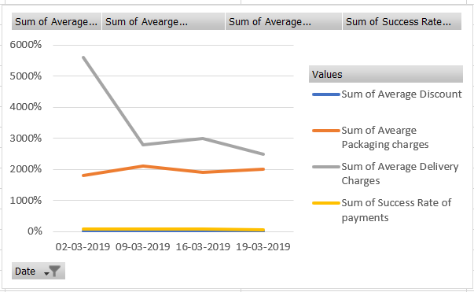

On 2nd March, the delivery charges are high when compared to other days but due to less packaging charges and high discount we could see good Order Intake

On 19th March, though the delivery charges are and low and discounts are high with 19%, the successful payments made are only 65%

April

|  |  |  |  |  |
| --- | --- | --- | --- | --- |
| Conversion rates | | | | |
| Row Labels | Sum of L2M | Sum of M2C | Sum of C2P | Sum of P2O |
| 04-04-2019 | 26.25% | 20.00% | 69.35% | 77.90% |
| 11-04-2019 | 24.75% | 38.80% | 75.92% | 80.36% |
| 12-04-2019 | 24.50% | 38.00% | 73.00% | 81.18% |
| 14-04-2019 | 21.00% | 35.36% | 68.00% | 81.90% |
| 18-04-2019 | 23.75% | 67.20% | 73.00% | 78.72% |
| 19-04-2019 | 25.00% | 41.20% | 76.65% | 81.18% |
| 25-04-2019 | 25.00% | 38.40% | 69.35% | 84.46% |
| Grand Total | 170.25% | 278.96% | 505.27% | 565.70% |

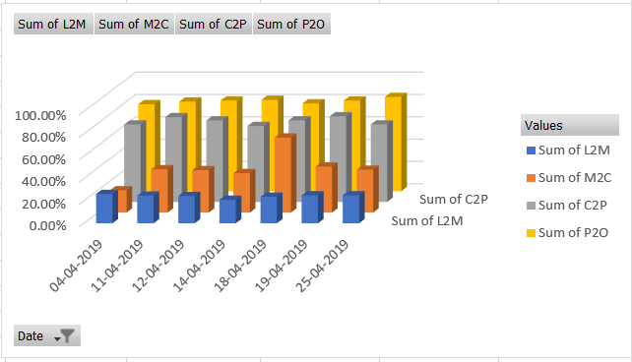

April sees a decline in L2M and M2C conversion rates

Average discount rates on 4th April is very low when compared to other days which is about 10% only

Whereas 18th April has highest discount rates of 29% but the successful payment ratio is only 91%

The traffic from all sources is unchanged

May

In the month of May, no Increase/decrease in trends were observed. This indicates a stable Order intake and metrics

June

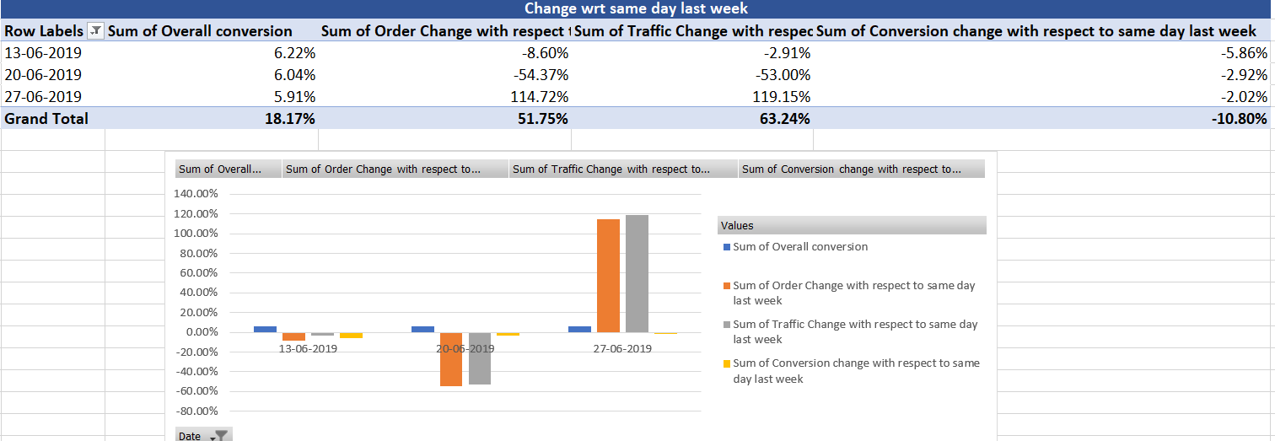

Order intake during this month is not affected by factors such as delivery charges or discounts

Instead we could see Order change rate when compared to last week same day is extremely high for 27th June when compared to 13th and 26th June

July

|  |  |  |  |  |
| --- | --- | --- | --- | --- |
| Conversion rates | | | | |
| Row Labels | Sum of L2M | Sum of M2C | Sum of C2P | Sum of P2O |
| 09-07-2019 | 24.75% | 39.60% | 73.73% | 82.00% |
| 16-07-2019 | 10.00% | 39.60% | 73.00% | 83.64% |
| 23-07-2019 | 23.75% | 39.60% | 75.19% | 77.90% |
| 26-07-2019 | 25.25% | 38.80% | 75.92% | 79.54% |
| Grand Total | 83.75% | 157.60% | 297.84% | 323.08% |

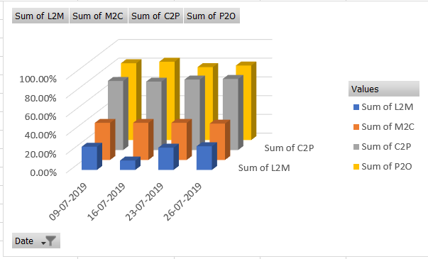

On 16th July, there is a decrease in L2M rate which is only 10% and it has a low conversion rate of 2.42%

Whereas on 23rd July, the order change rate is 135%

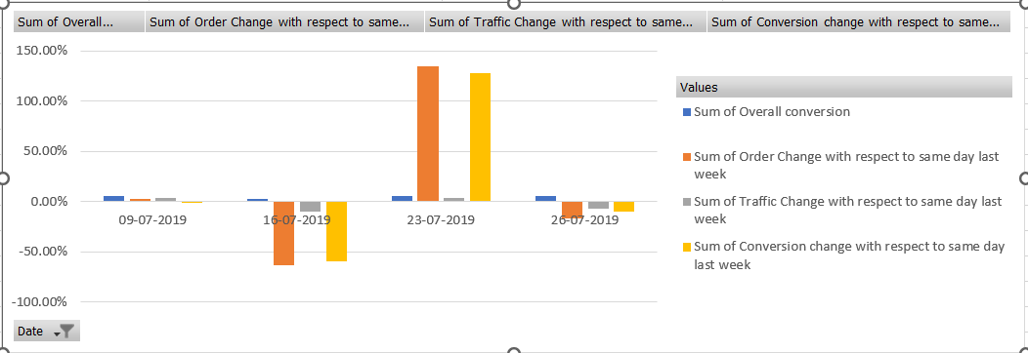

August

|  |  |  |  |  |
| --- | --- | --- | --- | --- |
| Conversion rates | | | | |
| Row Labels | Sum of L2M | Sum of M2C | Sum of C2P | Sum of P2O |
| 04-08-2019 | 20.58% | 32.30% | 70.72% | 81.12% |
| 11-08-2019 | 22.05% | 32.64% | 32.64% | 74.10% |
| 18-08-2019 | 21.00% | 32.98% | 64.60% | 78.00% |
| Grand Total | 63.63% | 97.92% | 167.96% | 233.22% |

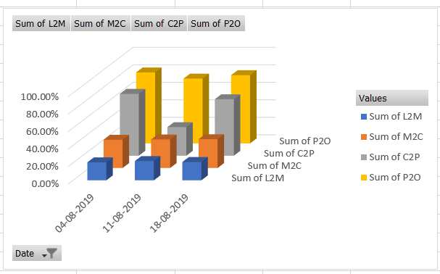

During the month of August, there is a slight decline in M2C conversion rate which is around 32% for peak dates

Adding to this, on 11th August, the C2P conversion rate is also less around 32.64% and it is less compared to other days.

September

|  |  |  |  |  |
| --- | --- | --- | --- | --- |
| Conversion rates | | | | |
| Row Labels | Sum of L2M | Sum of M2C | Sum of C2P | Sum of P2O |
| 14-09-2019 | 21.00% | 14.96% | 67.32% | 74.10% |
| 21-09-2019 | 20.16% | 34.34% | 64.60% | 74.88% |
| Grand Total | 41.16% | 49.30% | 131.92% | 148.98% |

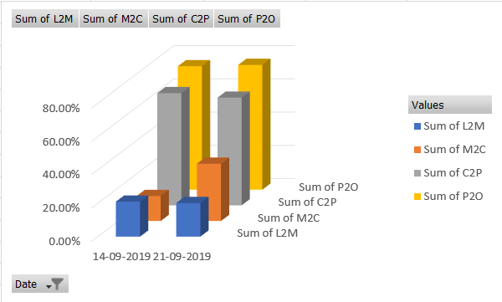

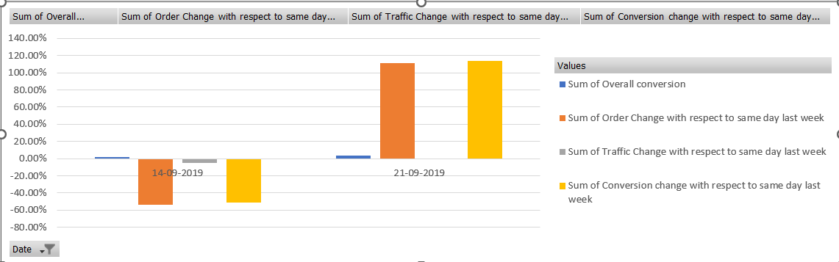

During September, we could again see a dip in M2C rates especially on 14th September which is only 14.96%

The Order change rate on 21st September is high when compared to 14th September

October

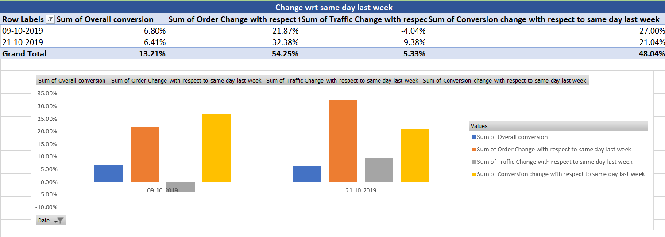

The Order change, traffic change and conversion change remains positive throughout the month and Overall conversion rate is also high

No extreme deviation is observed in conversion rates such as L2M, M2C, C2P and P2O during the month of October

|  |  |  |  |  |
| --- | --- | --- | --- | --- |
| Charges during peak days | | | | |
| Row Labels | Sum of Average Discount | Sum of Avearge Packaging charges | Sum of Average Delivery Charges | Sum of Success Rate of payments |
| 09-10-2019 | 19% | 19 | 29 | 91% |
| 21-10-2019 | 19% | 22 | 30 | 92% |
| Grand Total | 38% | 41 | 59 | 183% |

Discount percentage remains high a being a festive month and packaging and delivery charges remain stable

November

|  |  |  |  |  |
| --- | --- | --- | --- | --- |
| Conversion rates | | | | |
| Row Labels | Sum of L2M | Sum of M2C | Sum of C2P | Sum of P2O |
| 09-11-2019 | 21.21% | 34.68% | 68.00% | 80.34% |
| 17-11-2019 | 21.21% | 13.60% | 71.40% | 77.22% |
| 24-11-2019 | 21.00% | 34.00% | 65.96% | 75.66% |
| Grand Total | 63.42% | 82.28% | 205.36% | 233.22% |

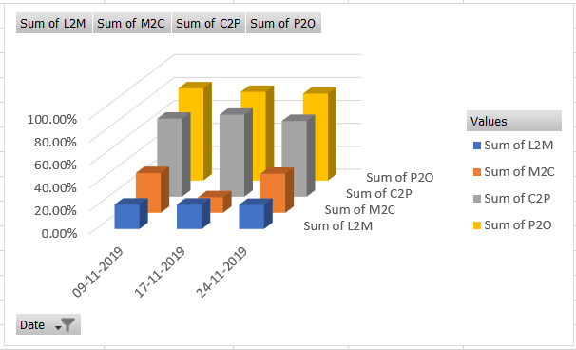

There is a dip in M2C conversion rate during the month of November and it is about 13.60% only.

|  |  |  |  |  |
| --- | --- | --- | --- | --- |
| Charges during peak days | | | | |
| Row Labels | Sum of Average Discount | Sum of Avearge Packaging charges | Sum of Average Delivery Charges | Sum of Success Rate of payments |
| 09-11-2019 | 19% | 21 | 27 | 93% |
| 17-11-2019 | 19% | 22 | 27 | 95% |
| 24-11-2019 | 19% | 22 | 27 | 95% |
| Grand Total | 57% | 65 | 81 | 283% |

Successful payment percentage remains high during this month with 95%

December

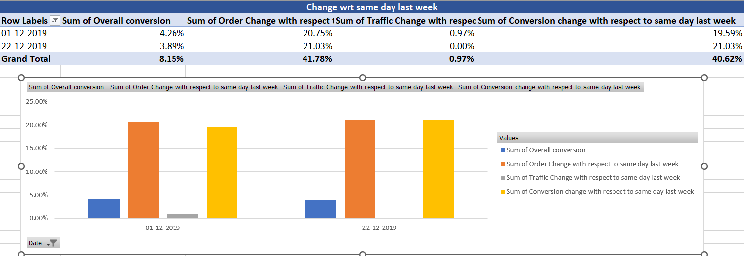

Metrics such as Order change, Traffic change and conversion change remain positive when compared to same day last week remains positive during the peak dates 1st and 22nd December

Conclusion

From the Analysis done on Swiggy’s performance we can infer,

1. Fluctuations in various sources of traffic is observed during the month of January
2. During the month of March there is a spike in unsuccessful payments from the consumer when compared to other months
3. Delivery and Packaging charges directly affect the order intake
4. Lack of options of various restaurants plays a major role in Order intake

Recommendations

1. Alternative payment methods or vendors can be included to avoid unsuccessful payment attempts from the consumers
2. Delivery partners have to be aligned with respect to count of orders we receive during the day. Additional delivery partners can be aligned during hours when high orders are expected.
3. Delivery can be extended to surrounding regions to expand business
4. Restaurant networks can be spread more to give consumers wide variety of options.